**CHAPTER 1**

**INTRODUCTION**

**1.1. HISTORICAL BACKGROUND**

***PAMANTASAN NG LUNGSOD NG MAYNILA***

*A Vision for Social Transformation*

Pamantasan ng Lungsod ng Maynila's conception started during the administration of Mayor Arsenio H. Lacson, the first elective mayor of the City of Manila in 1951, when he approved Ordinance No. 4202 on 13 January 1960. The Municipal Board has allocated P1-Million to establish the University. The Board's committee that spearheaded and allocated funds for the creation of the city university, in support of Mayor Lacson's educational program, was chaired by then-Councilor Ernesto M. Maceda. Mayor Lacson suddenly passed away while in office and before the fulfillment of his dream university. His then-Vice-Mayor, Antonio Villegas, succeeded him and worked for the realization of the dream university of his predecessor. On 13 February 1963, Mayor Villegas issued Executive Order No. 7, s-1963, creating a Planning and Working Committee to draw up a plan to establish the city university. The committee was chaired by Dr. Benito F. Reyes and the members were Gabriel Formoso, Leoncio Monzon, Alfredo Morales, Vicente Albano Pacis, Jose S. Roldan, and Carlos Moran Sison, with Atty. Primitivo de Leon as its secretary.

*Creation by National Legislation*

In 1964, Mayor Villegas co-opted the aid of then-Congressman Justo R. Albert of the 4th congressional district of the City of Manila to sponsor a bill in the House of Representatives of the Congress of the Philippines seeking to create the city university. Filed as House Bill No. 8349 in the Lower House, the Senate version was spearheaded by Senators Gil Puyat and Camilo Osias. In his explanatory note for H.B. 8349, Congressman Albert stressed that "the establishment of this university by the City of Manila will spur other cities in the country to exert similar efforts so that the responsibility of educating our people may be properly   
located." He articulated that according to a French philosopher, "next to food, education is the greatest need of the People." He likewise emphasized that "to permit the continuing control of education in the hands of big corporations is a tragic renunciation by the Government of a sacred obligation to our people. This bill envisions a partial relief of education from the grip of profit-motivated corporations and seeks a condition in which education is solely dedicated to the better instruction of our people."

The consolidation of the two bills was tackled during the Fourth Session of the Fifth Congress which began and was held in the City of Manila on 25 January 1965. The consolidated bill was thereafter passed by the joint Congress with the House of Representatives finally passing the same on 12 May 1965 while the Philippine Senate finally passed it on 07 June 1965. The final bill was signed by Senate President Ferdinand E. Marcos and House Speaker Cornelio T. Villareal with Mr. Regino S. Eustaquio, Secretary of the Senate, and Mr. Inocencio B. Pareja, Secretary of the House of Representatives.

*Presidential Approval of the Congressional Act*

On 19 June 1965, the final bill entitled "An Act Authorizing the City of Manila to Establish and Operate the University of the City of Manila and for Other Purposes" was signed into law by President Diosdado P. Macapacal in a signing ceremony in Malacañang Palace witnessed by Atty. Primitivo de Leon, Mayor Villegas, Congressman Ramon Mitra Jr., and its main sponsor in the House of Representatives, Congressman Albert. The law was captioned as Republic Act No. 4196 which now serves as the University Charter.

*A Day of Double Significance*

The birth of Pamantasan on a June 19 is made even more significant than ever by the fact that it was made to coincide with the birth of the Philippine national hero, Dr. Jose P. Rizal, who has a great aptitude for study, thereby earning several degrees and titles during his teen years with flying colors. Multi-talented as he was, Rizal's concept of the importance of education is clearly enunciated in his work entitled Instruction. For Rizal, the mission of education is to elevate the country to the highest seat of glory and to develop the people’s mentality. Since education is the foundation of society and a prerequisite for social progress, Rizal claimed that only through education could the country be saved from its sorry status. Rizal’s philosophy of education, therefore, centers on the provision of proper motivation in order to bolster the great social forces that make education a success, to create in the youth an innate desire to cultivate his intelligence and give him life eternal.

*The Seminal Direction*

The University was so named "Pamantasan ng Lungsod ng Maynila" from the official English name by Mayor Villegas in 1967. The Board of Regents, which is the governing body of the University, was formally formed in the same year as Mayor Villegas appointed its members. The university regents were sworn into office on 09 January 1967 which eventually conducted its first official board meeting and the election of its officers on 23 February 1967 at the Maharnilad. The composition of the first Board of Regents were: Atty. Carlos Moran Sison, chairman; Dr. Benito F. Reyes, vice-chairman; Emilio Abello, Roman F. Lorenzo, Jose S. Roldan and Primo L. Tongko, members; while Fructuoso R. Yanson served as an ex-officio member and Jose F. Sugay as its secretary. Dr. Reyes was elected as PLM's pioneer president, endowed with a herculean task of charting the roots of excellence that was to be the Pamantasan that is known today.

On February 5, 1970, then Executive Secretary Ernesto M. Maceda, by authority of then President Ferdinand Marcos, conveyed unto the City of Manila two (2) parcels of land owned by the Republic of the Philippines. Said real properties consist the area where PLM stands today. And as solemnly endeared and inscribed by every PLM member to his heart, the University formally opened the University College on Monday, 17 July 1967 with an initial enrollment of 556 outstanding and bright scholars carefully selected from the upper 10% of the various public high schools in Manila. Indeed, excellence has been a "birthright" of PLM. The PLM also established the Graduate College a year later, followed by the Institute for Extra-Mural Studies. And the rest was history in the making.

**VISION** (What we are)

The Pamantasan ng Lungsod ng Maynila (PLM), created by a National Charter (RA 4196, 1965), was envisioned to be Manila's premiere institution for higher learning. It provides superior standards of instructions, as well as opportunities for outstanding research in technology and other areas for the development of the intellect and to advance human knowledge.

The Pamantasan ng Lungsod ng Maynila has adopted the policy of preferential option for the poor and therefore has prioritized education for the underprivileged but talented students of Manila. Committed to the highest intellectual and ethical standards, PLM strives to produce competent graduates with integrity who will be responsible citizens who can contribute effectively to local, national and global initiatives for the progressive and sustainable development of humanity.

Guided by the values of academic excellence, integrity and social responsibility PLM endeavors to be one of the leading universities in the ASEAN.

* 1. **Organizational Chart**
     1. **Company as a whole**

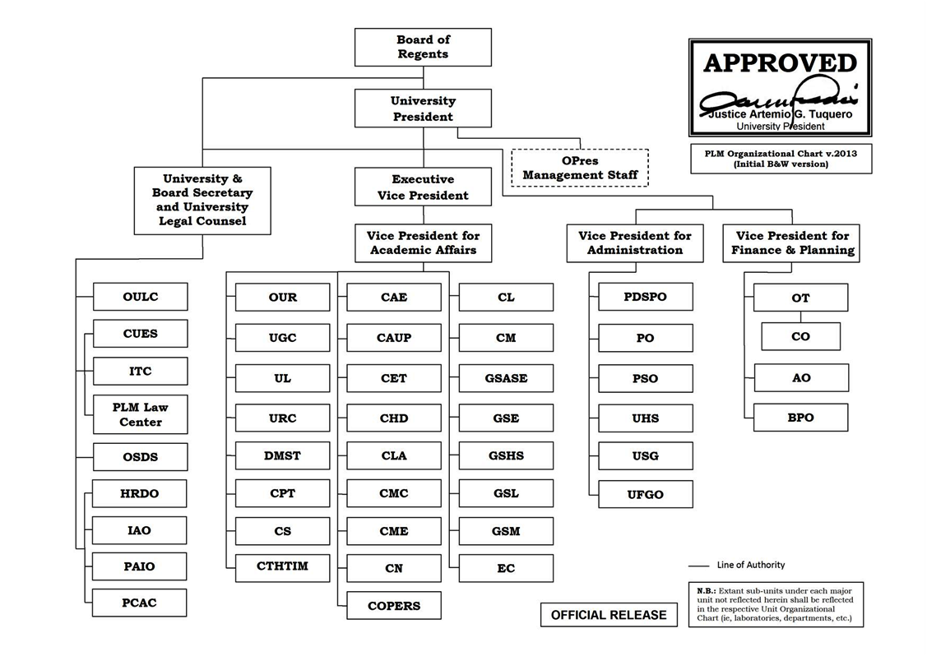

* + 1. 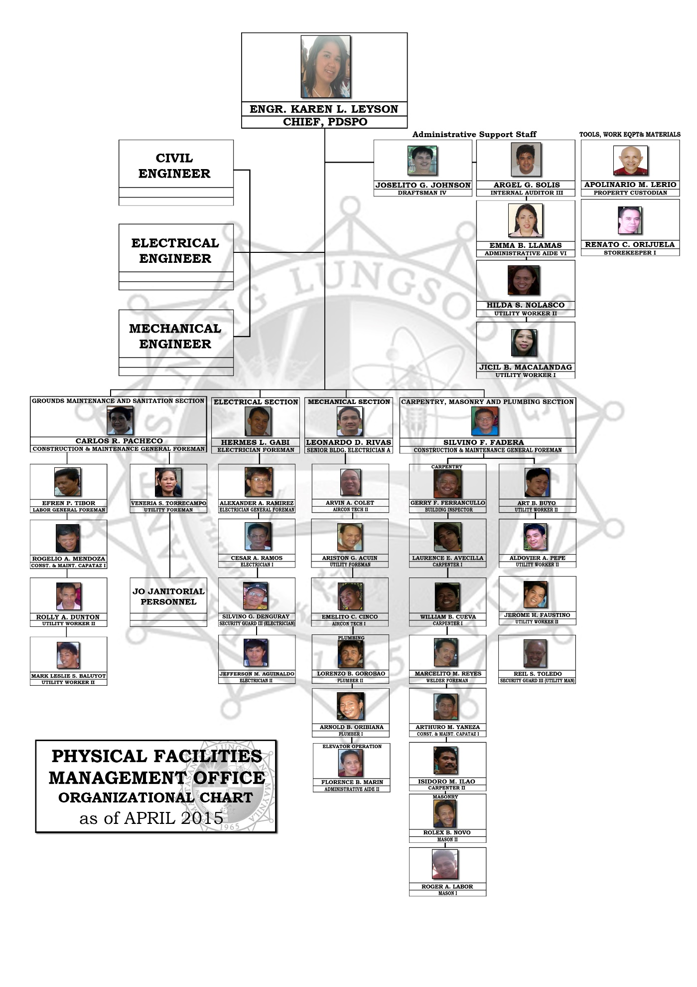**Division Understudy**
  1. **Statement of the problem**

**Problem 1: Slow and Tedious process of borrowing and returning of items and equipment.**

* **Documents Involved**

**Borrower’s Slip –** contains the borrower’s name, the item/s to be borrowed and its quantity.

**Logbook –** contains the borrower’s name, the item/s to be borrowed and its quantity.

**Draft Paper –** contains the borrower’s name, the item/s to be borrowed and its quantity.

**Ledger –** contains the borrower’s name, the item/s to be borrowed and its quantity.

**P.L.M I.D –** contains name and I.D number. Used as collateral when borrowing items.

* **Scenario**

In borrowing material/equipment, a borrower’s slip is filled-up with the name of the borrower, item to be borrowed and quantity to be borrowed. The Personnel will collect the borrower’s slip and checks if the item and quantity to be borrowed is available. If available, the personnel takes the I.D of the borrower then lends the item to him/her. Once the borrower has left with the item he/she has borrowed, the personnel inputs those data into a logbook and a draft paper. And on the ledger, which every item has its total quantity inputted, the quantity is subtracted.

In returning material/equipment, the borrower returns to the personnel with the items he/she has borrowed. The personnel checks the items for damages. If damaged, borrower is asked to pay for the replacement of the item. Once the borrower has left with his/her I.D, the personnel updates the logbook, draft paper, and ledger.

* **Cause**

Too many forms to fill up

Items stock card are searched in a clutter of stock card ledgers

* **Impact**

Consumes a lot of time and effort when the custodian issues or receives items

Delay in receiving or issuance of items borrowed

* **Quantification**

Logbook = 1

Draft paper = 1

The Procurement supplies were categorized as follows:

Electrical Supplies

Electro-Mechanical (Air-con) Supplies

Hardware (Carpentry) Supplies

Janitorial Supplies

Painting and Varnishing Supplies

Plumbing Supplies

Average of 100 items per category

100 x 6 = 600

Ledger = 1 per item

Electrical Supply - Fluorescent Lighting Fixture

- Fluorescent Lamp

Janitorial Supplies - Soft Broom (Tambo)

- Air Freshener

- Scouring Pad

- Cleanser (Scouring) Powder

- Toilet Deodorant Cake

- Mop Handle

- Mop Head

- Floor Wax

**Problem 2: No existing process of tracking of special project supplies.**

* **Documents Involved**

Letter of Request – A formal letter which is composed of the lists of all supplies issued

Delivery Receipt – A list of the supplies delivered in the property office

**Scenario**

Supplies for Project A are delivered to the stockroom and other supplies for other projects was placed on the same stockroom where the supplies for the Project A are in. Upon preparing for the special project, the personnel came to the stockroom to get the supplies needed for Project A, the personnel who will get the supply will tend to get the supplies even it is not allocated for their project. The supplies are not recorded as the personnel obtained it.

* **Cause**

Records of the Supplies relies only on the Delivery Receipt from the Property OfficeUntracked Distribution of Special Project supplies.

* **Impact**

Loss of supplies for other projects

Supplies and Equipment originally assigned to a specific project are shifted from one project to another to cover for the loss supplies/equipment causing mass dilemma.

* **Quantification**

Average Number of Special Project Materials handled in the Property Office per category: 1122

There are 6 Categories of Equipment: 1122 x 6 = 6732 Average Special Projects Items are handled in the Property Office of PFMO

**Problem 3: Management receives no real time update from the custodians for each tools, equipment and supplies issued or returned.**

* **Documents Involved**

**Borrower’s Slip –** contains the borrower’s name, the item/s to be borrowed and its quantity.

**Logbook –** contains the borrower’s name, the item/s to be borrowed and its quantity.

**Ledger –** contains the borrower’s name, the item/s to be borrowed and its quantity.

* **Scenario**

Every time an item or equipment is borrowed, received or returned in The PFMO, all transactions are tracked in the record book ONLY by the property custodian (under tools and equipment) and items are monitored through the stock cards ledgers. But the chief PFMO Department Head does not receive real-time updates from the inventory custodian about the transactions (issuance, receiving and returning of supplies & equipment, and who borrowed/received the item which is written in the logbook) except for the ledger report provided by the Property custodian.

* **Cause**

1. Irregular filing of the summarized ledger reports from the inventory custodian (under tools and equipment).   
   (Reports are not submitted daily and on a regular basis.)
2. Monitoring stock cards only includes the inventory custodian.

* **Impact**

1. The chief PFMO Department Head has limited knowledge and track of supplies and equipment in the property office.
2. The department head relies only on the report submitted by inventory custodian.

* **Quantification**

Logbook = 1

Draft paper = 1

The Procurement supplies were categorized as follows:

Electrical Supplies

Electro-Mechanical (Air-con) Supplies

Hardware (Carpentry) Supplies

Janitorial Supplies

Painting and Varnishing Supplies

Plumbing Supplies

Average of 100 per category

100 x 6 = 600

There are 6 Categories of Equipment: 1122 x 6 = 6732 Average Special Projects Items are handled in the Property Office of PFMO

An average of 7000 item transactions are not monitored by the PFMO Chief

* 1. **Scope and Limitation**

This study is about the current Supply and Inventory System of PDSPO in Pamantasan ng Lungsod ng Maynila. The school has an existing manual system of monitoring and listing of supplies. The focus of this is only on the supply and inventory system of the school and all other processes that are not covered and irrelevant to the system is out of our scope and out of our bounds to be discussed.

**CHAPTER 2**

**2.1 System Name and Background**

**Supply and Inventory Management and Tracking System**

This system is about the process of Supply and Inventory of PFMO (Physical Facilities Management Office) of Pamantasan ng Lungsod ng Maynila. From the manual listing and monitoring, to borrowing, returning, recording and issuance of different materials. Supplies under this system are the Procurement Supplies and Special Project Supplies. Under Procurement supplies, categories are given such as Electronic supplies, Electronics and Communication Supplies, Electro-Mechanical Supplies, Hardware Supplies, Janitorial Supplies, Painting and Varnishing Supplies and Plumbing Supplies. This is where quarterly supplies of different departments are issued and submitted to Management for evaluation, review and approval. Upon receipt of the approved budget, PFMO initiates corresponding request and all approved Request for Purchase of Materials are finally forwarded to the Procurement Office for appropriate action. All accepted request for procurement materials/supplies, are then delivered and stored on the stock room. Recording, issuance and control of procurement supplies are done using Materials Daily Issuance Record Sheet (MDIRS). On Special Project Supplies, these are the supplies needed for repairs and renovations for the improvement of the University. All request for the required supplies of their project, are then confirmed for approval and evaluation before delivering the needed materials to the stockroom. The recording, issuance and control of these materials are done the same way as the Procurement Supplies. Inventory for the supplies are done manually with ledgers, log book and stock cards.

**2.2 System Analysis Tools**

**2.2.1 System outline**

I. If Transaction is under Special Project

A. Supply Requisition and Receiving

1. Cost Estimate – PFMO Materials

2. CSW (Complete Staff Works) – Prepare PFMO

3. Attach Approved Drawing (if any)

4. Procurement Report – PFMO

5. Procurement Report Number- for Budget Office

6. Budget Utilization Request- Prepared by Budget Office

7. B.U.R number- Send to Procurement Office

8. B.U.R sent to PFMO chief for signature

9. Submit Complete Document to Procurement

10. Bidding Process

1. If cost is less than 500 000 VPA will sign

2. If Cost is Greater than 500 000 Office of the President will sign

3. If Cost is Greater than 5M Board of Reagents will sign

11. Procurement will issue P.O.

12. Give copy of P.O. to Property

13. Property will schedule delivery

14. Delivery will be evaluated by Technical Inspection Team

15. Deliver to PDSPO/PFMO

16. Schedule Project to start

17. Execute Project

B. Supply Distribution

1. Accept validated Project Request

2. Items/Equipment will be issued to requesting department or office

3. Issued items/equipment will be deducted to inventory reports

II. If Transaction is Quarterly Supplies

A. Supply Requisition and Receiving

1. Prepare for Quarter

2. CSW (Complete Staff Works) – Prepare PFMO for signature

3. Procurement office will issue PR No.

4. Property will inventory storage

5. If there is excess items

5.1. Issue Report why there is excess items or equipment

6. Budget Office will issue B.U.R. (Budget Utilization Request)

7. B.U.R number- Send to Procurement Office

8. B.U.R sent to PFMO chief for signature

9. Submit Complete Document to Procurement

10. Bidding Process

10.1 If cost is less than 500 000 VPA will sign

10.2 If Cost is Greater than 500 000 Office of the President will sign

10.3 If Cost is Greater than 5M Board of Reagents will sign

11. Procurement will issue P.O.

12. Give copy of P.O. to Property

13. Property will schedule delivery

14. Delivery will be evaluated by Technical Inspection Team

15. Deliver to PDSPO/PFMO

B. Supply Distribution

1. Items/Equipment will be issued to requesting department and offices

2. Issued items/equipment will be deducted to inventory reports

III. If Equipment and Tools Management

1. Equipment and Tools Borrowing and Issuance
2. Borrowing personnel will fill up and submit Borrower’s Slip with attached I.D.
3. Property Custodian will record the item borrowed in a separate record book
4. Property Custodian will issue the item to the borrower
5. Property Custodian will write the items borrowed in a separate draft paper
6. Property Custodian will search the specific stock card of an item in a pile of inventory ledgers
7. Property Custodian will deduct the item in the Quantity Section of the item stock card
8. Equipment and Tools Return
9. Give borrowed Item Back to property custodian
10. Validate Borrower’s Slip
11. Return I.D.
12. Property Custodian will search the specific stock card of an item in a pile of inventory ledgers
13. Property Custodian will update the item in the Quantity Section of the item stock card

**2.2.2 Flowchart**





























**2.2.3 Grid Chart**

|  |  |  |  |  |  |
| --- | --- | --- | --- | --- | --- |
|  | Student | College Office | Vice President | President | Board Of Regents |
|  |  |  |  |  |  |
| Approval Sheets |  |  | 1 | 1 | 1 |
| Request Letter |  | 1 |  |  |  |
| Special Project(Request Letter) |  | 1 |  |  |  |
| Borrower’s Slip | 1 |  |  |  |  |

**2.2.4 Context Diagram**

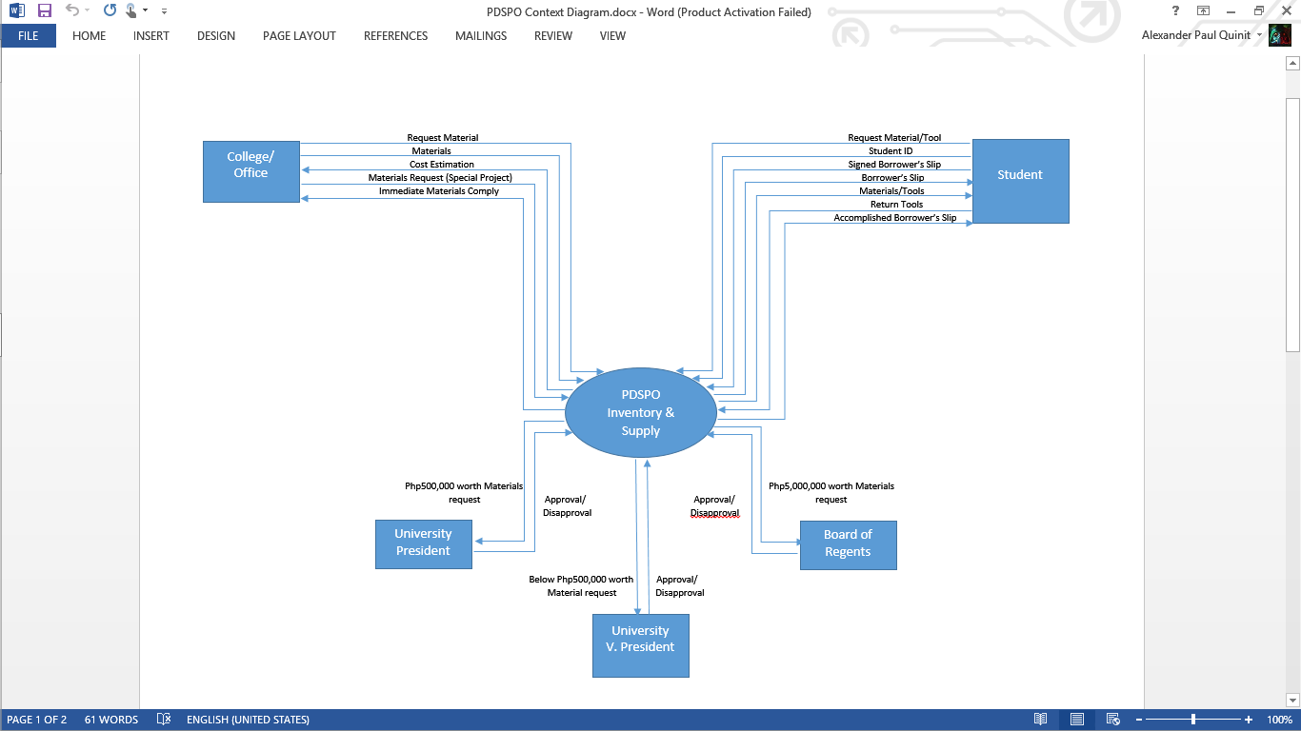

**2.2.5 Data Flow Diagram**



**2.2.6 Data Dictionary**

|  |  |  |  |
| --- | --- | --- | --- |
| Attribute | Length | Data Type | Description |
| Agency | 20 | Char | Name of Agency |
| Code | 10 | Alphanumeric | Code of the items |
| Item | 10 | Char | Name of Item |
| Description | 10 | Alphanumeric | Description of the item |
| Date | 10 | Int | Date |
| Receipt Quantity | 10 | Alphanumeric | Weight of the item before the release |
| Issuance Quantity | 5 | Alphanumeric | Weight of the items after the release |
| Office | 20 | Char | Name of the office who borrow |
| Balance Quantity | 5 | Alphanumeric | Quantity of the left item |

**2.2.7 User Requirement**

Some qualities and abilities are required from the user for the given process in the system to go well. The user should be computer literate, he/she should know the basics in using a computer and also for the system to work well. Basically the user should know how the process of the system works, and the connectivity of the network to the database, so that the manipulation of records are more efficient. The system should be user friendly, so that the user would understand how to use the system efficiently even he/she is not a specialist or an IT professional. Anyone that is computer literate, can use it well all throughout process.

**CHAPTER 3**

**GENERAL DESIGN**

**3.1 General Objectives**

The main objectives of the study are to apply the principle and concepts to provide a solution to the existing problems of the company and provide an automated management system for the Pamantasan ng Lungsod ng Maynila, Physical Facilities and Management Office Inventory and Supplies Management and Tracking Section.

**3.2 Specific Objectives**

The specific objectives of the study based on the problems stated:

1. To immediately check tools and equipment quantity in the inventory.

2. To directly track and monitor outgoing equipment, tools and supplies.

3. To update the Chief PFMO of received and issued equipment, tools and supplies from the three property sections (Special Projects, Quarterly Supplies, Equipment and Tools).

**3.3 Presentation of Alternatives**

**3.3.1 Alternative 1: Stand Alone Set-up**

Stand alone is a kind of set-up where all terminals are independent of each other. The system should also install to each other at the terminal having the same capabilities. The accessing level and capabilities of a user will be determined by its account level. This proposed set up will require the Property Custodian per office to have some terminal. The said office will be the following: Special Projects, Quarterly Supplies, Tools and Equipment. The proposed alternative will have the following advantages:

* Easy access of data needed: Data collected will be held by each database, thus retrieving of these will be independent of others.
* Less expensive: stand-alone system will be less expensive when compared to other type of set-up Local Area Network (LAN) or Wide Area Network (WAN)
* Data security: Data held by each terminal through their databases will not be accessed by other terminal

In this proposed alternative, the Property Custodian per section can access the system using their log-in username and log-in password. For example, the Property Custodian at Special Projects can access his/her appropriate module in the system after he/she log-in. He can check the available supplies in his respective stockroom. He will transfer the information about the available supplies in their section among other sections through the telephone.

**3.3.1.1 System Flowchart**

































 





**3.3.1.2 Physical Elements**



**3.3.1.2.1 Database/Table**

**User Database**

|  |  |  |  |  |
| --- | --- | --- | --- | --- |
|  | **Field Data** | **Field Type** | **Length** | **Description** |
|  |  |  |  |  |
|  | Username | Alphanumeric | 15 | Log-in username |
|  |  |  |  |  |
|  | Password | Alphanumeric | 15 | Log-in password |
|  |  |  |  |  |
|  | First Name | Alphabet | 15 | First name of |
|  |  |  |  | User |
|  | Last Name | Alphabet | 15 | Last name of |
|  |  |  |  | User |
|  | Middle Name | Alphabet | 15 | Middle name of |
|  |  |  |  | User |
|  | Position | Alphabet | 20 | Position of |
|  |  |  |  | User |
| **Quarterly Supplies Database** | | |  |  |
|  |  |  |  |  |
|  | **Field Data** | **Field Type** | **Length** | **Description** |
|  |  |  |  |  |
|  | Date Received | Alphanumeric | 15 | Date of Supply Requisition |
|  |  |  |  |  |
|  | Category | Alphanumeric | 15 | Supply Category |
|  |  |  |  |  |
|  | Brand | Alphabet | 15 | Supply Brand |
|  |  |  |  | Name |
|  | Supply Code | Alphabet | 15 | Supply Serial |
|  |  |  |  | Code |
|  | Supply Description | Alphabet | 15 | Description or Name |
|  |  |  |  | Of Supply |
|  | Stock | Numeric | 100 | Number of Supply in |
|  |  |  |  | Stockroom |
|  | In | Numeric | 100 | Number of Received |
|  |  |  |  | Supply |
|  | Out | Numeric | 100 | Number of Issued |
|  |  |  |  | Supply |

|  |  |  |  |  |  |  |
| --- | --- | --- | --- | --- | --- | --- |
| **Special Project Supplies Database** | | | |  |  | |
|  |  | |  |  |  | |
|  | **Field Data** | | **Field Type** | **Length** | **Description** | |
|  |  | |  |  |  | |
|  | Date Received | | Alphanumeric | 15 | Date of Supply Requisition | |
|  |  | |  |  |  | |
|  | Category | | Alphanumeric | 15 | Supply Category | |
|  |  | |  |  |  | |
|  | Brand | | Alphabet | 15 | Supply Brand | |
|  |  | |  |  | Name | |
|  | Supply Code | | Alphanumeric | 15 | Supply Serial | |
|  |  | |  |  | Code | |
|  | Supply Description | | Alphabet | 15 | Description or Name | |
|  |  | |  |  | Of Supply | |
|  | Stock | | Numeric | 100 | Number of Supply in | |
|  |  | |  |  | Stockroom | |
|  | In | | Numeric | 100 | Number of Received | |
|  |  | |  |  | Supply | |
|  | Out | | Numeric | 100 | Number of Issued | |
|  |  | |  |  | Supply | |
| Target Project | Alphabet | | 50 | | Target Project of the Supplies |

|  |  |  |  |  |
| --- | --- | --- | --- | --- |
| **Equipment and Tools Database** | | |  |  |
|  |  |  |  |  |
|  | **Field Data** | **Field Type** | **Length** | **Description** |
|  |  |  |  |  |
|  | Date Received | Alphanumeric | 15 | Date of Equipment or Tools Requisition |
|  |  |  |  |  |
|  | Category | Alphanumeric | 15 | Equipment or Tools Category |
|  |  |  |  |  |
|  | Brand | Alphabet | 15 | Equipment or Tools Brand |
|  |  |  |  | Name |
|  | Equipment or Tools | Alphabet | 15 | Equipment or Tools Serial |
|  | Code |  |  | Code |
|  | Description | Alphabet | 15 | Description or Name |
|  |  |  |  | Of Equipment or Tools |
|  | Stock | Numeric | 100 | Stock of Equipment or Tools in |
|  |  |  |  | Stockroom |
|  | In | Numeric | 100 | Number of Received |
|  |  |  |  | Equipment or Tools |
|  | Out | Numeric | 100 | Number of Issued |
|  |  |  |  | Equipment or Tools |

**3.3.1.2.2 Reports**

The following are the reports generated by the proposed system:

* INVENTORY REPORT- Contains the total number of remaining stocks of supplies, equipment and tools.
* PROJECT MATERIAL REPORT- Contains the total number of remaining materials per project, and the project materials acquired by the designated college/ receiver.

Manual Process (Existing)

* Issuance of Borrower slip
* Filling up of borrower slip
* Submission of ID of students/staff
* Acceptance of delivery receipt

**Requirements Definition**

|  |  |  |  |
| --- | --- | --- | --- |
| **Items** | **Required** | **Existing** | **Needed** |
| **Hardware**  Personal Computer Definition (HP Compaq DC5800 Intel Core 2 Duo E8400 3.0GHz / 2GB DDR2 /  320GB SATA HDD /  On Board Video Card 384MB / DVD-ROM with IBM THinkVision L190p 19-inch LCD Monitor)  **Software**  Operating System Windows 7 (Ultimate) Printer Canon IP Pixma 2770 | **4**  **4**  **4** | **0**  **0**  **0** | **4**  **4**  **4** |

**COST & BENEFIT ANALYSIS**

|  |  |
| --- | --- |
| **Items** | **Cost** |
| One time Cost  **Hardware**  (4) Personal Computer  (HP Compaq DC5800  Intel Core 2 Duo E8400 3.0GHz /  2GB DDR2 /  320GB SATA HDD /  On Board Video Card 384MB /  DVD-ROM with IBM THinkVision  L190p 19-inch LCD Monitor)  (PHP 11,780.00 each)  **Software**  **(4)**Operating System Windows 7 (Ultimate) Printer Canon IP Pixma 2770 (PHP 2,265.00 each) | PHP 47,120.00  PHP 9,060.00 |
| TOTAL ONE TIME COST |  |
| RECURRING COST  **Maintenance**  Money Allotted for Computer Problems (Both Hardware and Software) (PHP 1,000.00 each)  **Electricity Cost**  Monthly Cost of Computers and printers  **Printer Cost**  CISS Dye Ink | PHP 4,000.00  PHP 8,000.00  PHP 2,500.00 |
| ***TOTAL RECURRING COST :*** | **PHP 14,500.00** |
| ***TOTAL COST:*** | **PHP 70,680.00** |

**Tangible/Intangible Benefits**

1. Easy access of the information of availability, critical level of an equipment and tools

2. Terminate unnecessary workloads.

3. Real-time updating of in and out going project materials, supplies and equipment and tools

4. Centralized data is secure and easy to backup.

5. Essential summary of reports for good-decision making.

6. Delay in making reports will be prevented

**3.3.2 Alternative 2: Centralized Set-Up**

The second alternative is a centralized set-up of the system. This kind of system setup will need the respective custodians to have at least one terminal each that is connected to the server with the use of a telephone jack or computer networking equipment. Each terminal must install the proposed system in order to access it.

The accessibility of the system depends on the position of the users. Because the system is centralized, the PFMO chief can access all the reports on each area and print it whenever needed. Also, access a real time update on the availability of supplies and items.

The proposed alternative will have the following advantages:

• Data security – only the main server can access all the reports.

• Less expensive- centralized set-up is less expensive compared to other types of set-up.

• Reliability of Data – the greatest benefit of centralizing a company’s data management is reliability of data. One of the basic rules in database design is that no redundancy is allowed. A centralized database means that each member has one primary record.

**3.3.2.1 System Flowchart**

























 











**3.3.2.2 Physical Elements**



**3.3.2.2.1 Database/Table**

**User Database**

|  |  |  |  |  |
| --- | --- | --- | --- | --- |
|  | **Field Data** | **Field Type** | **Length** | **Description** |
|  |  |  |  |  |
|  | Username | Alphanumeric | 15 | Log-in username |
|  |  |  |  |  |
|  | Password | Alphanumeric | 15 | Log-in password |
|  |  |  |  |  |
|  | First Name | Alphabet | 15 | First name of |
|  |  |  |  | User |
|  | Last Name | Alphabet | 15 | Last name of |
|  |  |  |  | User |
|  | Middle Name | Alphabet | 15 | Middle name of |
|  |  |  |  | User |
|  | Position | Alphabet | 20 | Position of |
|  |  |  |  | User |
| **Quarterly Supplies Database** | | |  |  |
|  |  |  |  |  |
|  | **Field Data** | **Field Type** | **Length** | **Description** |
|  |  |  |  |  |
|  | Date Received | Alphanumeric | 15 | Date of Supply Requisition |
|  |  |  |  |  |
|  | Category | Alphanumeric | 15 | Supply Category |
|  |  |  |  |  |
|  | Brand | Alphabet | 15 | Supply Brand |
|  |  |  |  | Name |
|  | Supply Code | Alphabet | 15 | Supply Serial |
|  |  |  |  | Code |
|  | Supply Description | Alphabet | 15 | Description or Name |
|  |  |  |  | Of Supply |
|  | Stock | Numeric | 100 | Number of Supply in |
|  |  |  |  | Stockroom |
|  | In | Numeric | 100 | Number of Received |
|  |  |  |  | Supply |
|  | Out | Numeric | 100 | Number of Issued |
|  |  |  |  | Supply |

|  |  |  |  |  |  |  |
| --- | --- | --- | --- | --- | --- | --- |
| **Special Project Supplies Database** | | | |  |  | |
|  |  | |  |  |  | |
|  | **Field Data** | | **Field Type** | **Length** | **Description** | |
|  |  | |  |  |  | |
|  | Date Received | | Alphanumeric | 15 | Date of Supply Requisition | |
|  |  | |  |  |  | |
|  | Category | | Alphanumeric | 15 | Supply Category | |
|  |  | |  |  |  | |
|  | Brand | | Alphabet | 15 | Supply Brand | |
|  |  | |  |  | Name | |
|  | Supply Code | | Alphanumeric | 15 | Supply Serial | |
|  |  | |  |  | Code | |
|  | Supply Description | | Alphabet | 15 | Description or Name | |
|  |  | |  |  | Of Supply | |
|  | Stock | | Numeric | 100 | Number of Supply in | |
|  |  | |  |  | Stockroom | |
|  | In | | Numeric | 100 | Number of Received | |
|  |  | |  |  | Supply | |
|  | Out | | Numeric | 100 | Number of Issued | |
|  |  | |  |  | Supply | |
| Target Project | Alphabet | | 50 | | Target Project of the Supplies |

|  |  |  |  |  |
| --- | --- | --- | --- | --- |
| **Equipment and Tools Database** | | |  |  |
|  |  |  |  |  |
|  | **Field Data** | **Field Type** | **Length** | **Description** |
|  |  |  |  |  |
|  | Date Received | Alphanumeric | 15 | Date of Equipment or Tools Requisition |
|  |  |  |  |  |
|  | Category | Alphanumeric | 15 | Equipment or Tools Category |
|  |  |  |  |  |
|  | Brand | Alphabet | 15 | Equipment or Tools Brand |
|  |  |  |  | Name |
|  | Equipment or Tools | Alphabet | 15 | Equipment or Tools Serial |
|  | Code |  |  | Code |
|  | Description | Alphabet | 15 | Description or Name |
|  |  |  |  | Of Equipment or Tools |
|  | Stock | Numeric | 100 | Stock of Equipment or Tools in |
|  |  |  |  | Stockroom |
|  | In | Numeric | 100 | Number of Received |
|  |  |  |  | Equipment or Tools |
|  | Out | Numeric | 100 | Number of Issued |
|  |  |  |  | Equipment or Tools |

**3.3.2.2.2 Reports**

The following are the reports generated by the proposed system:

* INVENTORY REPORT- Contains the total number of remaining stocks of supplies, equipment and tools.
* PROJECT MATERIAL REPORT- Contains the total number of remaining materials per project, and the project materials acquired by the designated college/ receiver.

Manual Process (Existing)

* Issuance of Borrower slip
* Filling up of borrower slip
* Submission of ID of students/staff
* Acceptance of delivery receipt

**REQUIREMENTS DEFINITION**

|  |  |  |  |
| --- | --- | --- | --- |
| **Items** | **Required** | **Existing** | **Needed** |
| ***Hardware***  Personal Computer Definition (HP Compaq DC5800 Intel Core 2 Duo E8400 3.0GHz / 2GB DDR2 /  320GB SATA HDD /  On Board Video Card 384MB / DVD-ROM with IBM THinkVision L190p 19-inch LCD Monitor)  ***Software***  Operating System Windows 7 (Ultimate) ***Printer***  Canon IP Pixma 2770  ROUTER  Ethernet cable With Unshielded Twisted pair ( RJ-45) | **4**  **4**  **4**  **1**  **100 meters** | **0**  **0**  **0**  **0**  **0** | **4**  **4**  **4**  **0**  **100 meters** |

**COST & BENEFIT ANALYSIS**

|  |  |
| --- | --- |
| **Items** | **Cost** |
| **One time Cost**  **Hardware**  (4) Personal Computer  (HP Compaq DC5800  Intel Core 2 Duo E8400 3.0GHz /  2GB DDR2 /  320GB SATA HDD /  On Board Video Card 384MB /  DVD-ROM with IBM THinkVision  L190p 19-inch LCD Monitor)  (PHP 11,780.00 each)  ROUTER  Ethernet Cable with  Unshielded Twisted pair ( RJ-45)  **Software**  **(4)**Operating System Windows 7 (Ultimate) Printer Canon IP Pixma 2770 (PHP 2,265.00 each) | PHP 47,120.00  PHP 1,000.00  PHP 580.00  PHP 9,060.00 |
| **TOTAL ONE TIME COST** | **PHP 57,760.00** |
| **RECURRING COST**  **Maintenance**  Money Allotted for Computer Problems (Both Hardware and Software) (PHP 1,000.00 each)  **Electricity Cost**  Monthly Cost of Computers and printers  **Printer Cost**  CISS Dye Ink | PHP 4,000.00  PHP 8,000.00  PHP 2,500.00 |
| **TOTAL RECURRING COST :** | **PHP 14,500.00** |
| **TOTAL COST:** | **PHP 72,260.00** |

**Tangible/Intangible Benefits**

1. Easy access of the information of availability, critical level of an equipment and tools

2. Terminate unnecessary workloads.

3. Real-time updating of in and out going project materials, supplies and equipment and tools

4. Centralized data is secure and easy to backup.

5. Essential summary of reports for good-decision making.

6. Delay in making reports will be prevented

**3.3.3 Alternative 3: Web Application Set-Up (Internet Based Network System)**

Web application is a kind of set-up where the system will require each of the custodians to have one terminal. The said custodians will be the following: Special Projects Supplies, Quarterly Supplies, Equipment and Tools. One computer designated at the Admitting and Discharge Section and one for each custodians. The proposed system is assigned a specific address in the web so that users could access it.

The proposed system can be used as long as the employees are connected to the internet and logged in. The distinct custodians will be their usernames and they will create their own passwords for security purposes and it will be having user levels. The system can only be accessed by the user according to their level. The PFMO Chief could access all the reports on each level by the use of internet and can print it whenever needed. The Management Office could access a real time update on the availability of supplies and items.

The proposed alternative will have the following advantages:

• Convenient – as long as there is internet connection and the employee is logged in, the system will be available.

• Secured – information is protected against incidence of system failure

• Cheaper – this cost lesser than market software

• Portability – the system can be used as long as employee is connected to the internet and logged in using any computer.

• Real time - can be updated easily

• Census is regularly updated and can be generated.

By this, we can minimize human errors and the updates can be regularly done.

**3.3.3.1 System Flowchart**















 





















**3.3.3.2 Physical Elements**



**3.3.3.2.1 Database/Table**

**User Database**

|  |  |  |  |  |
| --- | --- | --- | --- | --- |
|  | **Field Data** | **Field Type** | **Length** | **Description** |
|  |  |  |  |  |
|  | Username | Alphanumeric | 15 | Log-in username |
|  |  |  |  |  |
|  | Password | Alphanumeric | 15 | Log-in password |
|  |  |  |  |  |
|  | First Name | Alphabet | 15 | First name of |
|  |  |  |  | User |
|  | Last Name | Alphabet | 15 | Last name of |
|  |  |  |  | User |
|  | Middle Name | Alphabet | 15 | Middle name of |
|  |  |  |  | User |
|  | Position | Alphabet | 20 | Position of |
|  |  |  |  | User |
| **Quarterly Supplies Database** | | |  |  |
|  |  |  |  |  |
|  | **Field Data** | **Field Type** | **Length** | **Description** |
|  |  |  |  |  |
|  | Date Received | Alphanumeric | 15 | Date of Supply Requisition |
|  |  |  |  |  |
|  | Category | Alphanumeric | 15 | Supply Category |
|  |  |  |  |  |
|  | Brand | Alphabet | 15 | Supply Brand |
|  |  |  |  | Name |
|  | Supply Code | Alphabet | 15 | Supply Serial |
|  |  |  |  | Code |
|  | Supply Description | Alphabet | 15 | Description or Name |
|  |  |  |  | Of Supply |
|  | Stock | Numeric | 100 | Number of Supply in |
|  |  |  |  | Stockroom |
|  | In | Numeric | 100 | Number of Received |
|  |  |  |  | Supply |
|  | Out | Numeric | 100 | Number of Issued |
|  |  |  |  | Supply |

|  |  |  |  |  |  |  |
| --- | --- | --- | --- | --- | --- | --- |
| **Special Project Supplies Database** | | | |  |  | |
|  |  | |  |  |  | |
|  | **Field Data** | | **Field Type** | **Length** | **Description** | |
|  |  | |  |  |  | |
|  | Date Received | | Alphanumeric | 15 | Date of Supply Requisition | |
|  |  | |  |  |  | |
|  | Category | | Alphanumeric | 15 | Supply Category | |
|  |  | |  |  |  | |
|  | Brand | | Alphabet | 15 | Supply Brand | |
|  |  | |  |  | Name | |
|  | Supply Code | | Alphanumeric | 15 | Supply Serial | |
|  |  | |  |  | Code | |
|  | Supply Description | | Alphabet | 15 | Description or Name | |
|  |  | |  |  | Of Supply | |
|  | Stock | | Numeric | 100 | Number of Supply in | |
|  |  | |  |  | Stockroom | |
|  | In | | Numeric | 100 | Number of Received | |
|  |  | |  |  | Supply | |
|  | Out | | Numeric | 100 | Number of Issued | |
|  |  | |  |  | Supply | |
| Target Project | Alphabet | | 50 | | Target Project of the Supplies |

|  |  |  |  |  |
| --- | --- | --- | --- | --- |
| **Equipment and Tools Database** | | |  |  |
|  |  |  |  |  |
|  | **Field Data** | **Field Type** | **Length** | **Description** |
|  |  |  |  |  |
|  | Date Received | Alphanumeric | 15 | Date of Equipment or Tools Requisition |
|  |  |  |  |  |
|  | Category | Alphanumeric | 15 | Equipment or Tools Category |
|  |  |  |  |  |
|  | Brand | Alphabet | 15 | Equipment or Tools Brand |
|  |  |  |  | Name |
|  | Equipment or Tools | Alphabet | 15 | Equipment or Tools Serial |
|  | Code |  |  | Code |
|  | Description | Alphabet | 15 | Description or Name |
|  |  |  |  | Of Equipment or Tools |
|  | Stock | Numeric | 100 | Stock of Equipment or Tools in |
|  |  |  |  | Stockroom |
|  | In | Numeric | 100 | Number of Received |
|  |  |  |  | Equipment or Tools |
|  | Out | Numeric | 100 | Number of Issued |
|  |  |  |  | Equipment or Tools |

**3.3.3.2.2 Reports**

The following are the reports generated by the proposed system:

* INVENTORY REPORT- Contains the total number of remaining stocks of supplies, equipment and tools.
* PROJECT MATERIAL REPORT- Contains the total number of remaining materials per project, and the project materials acquired by the designated college/ receiver.

Manual Process (Existing)

* Issuance of Borrower slip
* Filling up of borrower slip
* Submission of ID of students/staff
* Acceptance of delivery receipt

**REQUIREMENT DEFINITION**

|  |  |  |  |
| --- | --- | --- | --- |
| **Items** | **Required** | **Existing** | **Needed** |
| **Hardware**  -Personal Computer Definition (HP Compaq DC5800 Intel Core 2 Duo E8400 3.0GHz / 2GB DDR2 /  320GB SATA HDD /  On Board Video Card 384MB / DVD-ROM with IBM THinkVision L190p 19-inch LCD  Monitor)  -ROUTER  **Software**  -Operating System Windows 7 (Ultimate) ***Printer***  Canon IP Pixma 2770  Network Cable with RJ-45 | **4**  **1**  **4**  **4**  **100 meter** | **0**  **0**  **0**  **0**  **0** | **4**  **1**  **4**  **4**  **100 meter** |

**COST AND BENEFIT ANALYSIS**

|  |  |
| --- | --- |
| **Items** | **Cost** |
| **One time Cost**  **Hardware**  (4) Personal Computer  (HP Compaq DC5800  Intel Core 2 Duo E8400 3.0GHz /  2GB DDR2 /  320GB SATA HDD /  On Board Video Card 384MB /  DVD-ROM with IBM THinkVision  L190p 19-inch LCD Monitor)  (PHP 11,780.00 each)  **ROUTER & Internet connection**  **Network cable and Rj-45**  **Software**  **(4)**Operating System Windows 7 (Ultimate) Printer Canon IP Pixma 2770 (PHP 2,265.00 each) | PHP 47,120.00  PHP 2,000.00  PHP 580.00  PHP 9,060.00 |
| **TOTAL ONE TIME COST** | **PHP 57,760.00** |
| **RECURRING COST**  **Maintenance**  Money Allotted for Computer Problems (Both Hardware and Software) (PHP 1,000.00 each)  **Electricity Cost**  Monthly Cost of Computers and printers  **Printer Cost**  CISS Dye Ink    Monthly Internet Connection | PHP 4,000.00  PHP 8,000.00  PHP 2,500.00  PHP 1,000.00 |
| ***TOTAL RECURRING COST :*** | **PHP 15,500.00** |
| ***TOTAL COST:*** | **PHP 73,760.00** |

**Tangible/Intangible Benefits**

1. Easy access of the information of availability, critical level of an equipment and tools

2. Terminate unnecessary workloads.

3. Real-time updating of in and out going project materials, supplies and equipment and tools

4. Centralized data is secure and easy to backup.

5. Essential summary of reports for good-decision making.

6. Delay in making reports will be prevented

**3.3.4 Alternative 4: Web Application Set-Up with Local Area Network (In case of Internet Loss, Disconnection or Malfunction)**

Web application is a kind of set-up where the system will require each of the custodians to have one terminal. The said custodians will be the following: Special Projects Supplies, Quarterly Supplies, Equipment and Tools. One computer designated at the Admitting and Discharge Section and one for each custodians. The proposed system is assigned a specific address in the web so that users could access it.

The proposed system can be used as long as the employees are connected to the internet and logged in. The distinct custodians will be their usernames and they will create their own passwords for security purposes and it will be having user levels. The system can only be accessed by the user according to their level. The PFMO Chief could access all the reports on each level by the use of internet and can print it whenever needed. The Management Office could access a real time update on the availability of supplies and items.

The proposed alternative will have the following advantages:

• Convenient – as long as there is internet connection and the employee is logged in, the system will be available.

• Secured – information is protected against incidence of system failure

• Cheaper – this cost lesser than market software

• Portability – the system can be used as long as employee is connected to the internet and logged in using any computer.

• Real time - can be updated easily

• Census is regularly updated and can be generated.

By this, we can minimize human errors and the updates can be regularly done.

In case of internet loss, disconnection or malfunction, transactions in the system is required to continue functioning thus a backup protocol must be implemented and executed in order for the transactions to not cease.

The backup alternative/protocol is a centralized set-up of the system. This kind of system setup will need the respective custodians to have at least one terminal each that is connected to the server with the use of a telephone jack or computer networking equipment. Each terminal must install the proposed system in order to access it.

The accessibility of the system depends on the position of the users. Because the system is centralized, the PFMO chief can access all the reports on each area and print it whenever needed. Also, access a real time update on the availability of supplies and items.

The proposed backup alternative will have the following advantages:

• Data security – only the main server can access all the reports.

• Less expensive- centralized set-up is less expensive compared to other types of set-up.

• Reliability of Data – the greatest benefit of centralizing a company’s data management is reliability of data. One of the basic rules in database design is that no redundancy is allowed. A centralized database means that each member has one primary record.

**3.3.4.1 System Flowchart**







































**3.3.4.2 Physical element**



**Backup Procedure and System Design**



**3.3.4.3 Database/Table**

**User Database**

|  |  |  |  |  |
| --- | --- | --- | --- | --- |
|  | **Field Data** | **Field Type** | **Length** | **Description** |
|  |  |  |  |  |
|  | Username | Alphanumeric | 15 | Log-in username |
|  |  |  |  |  |
|  | Password | Alphanumeric | 15 | Log-in password |
|  |  |  |  |  |
|  | First Name | Alphabet | 15 | First name of |
|  |  |  |  | User |
|  | Last Name | Alphabet | 15 | Last name of |
|  |  |  |  | User |
|  | Middle Name | Alphabet | 15 | Middle name of |
|  |  |  |  | User |
|  | Position | Alphabet | 20 | Position of |
|  |  |  |  | User |
| **Quarterly Supplies Database** | | |  |  |
|  |  |  |  |  |
|  | **Field Data** | **Field Type** | **Length** | **Description** |
|  |  |  |  |  |
|  | Date Received | Alphanumeric | 15 | Date of Supply Requisition |
|  |  |  |  |  |
|  | Category | Alphanumeric | 15 | Supply Category |
|  |  |  |  |  |
|  | Brand | Alphabet | 15 | Supply Brand |
|  |  |  |  | Name |
|  | Supply Code | Alphabet | 15 | Supply Serial |
|  |  |  |  | Code |
|  | Supply Description | Alphabet | 15 | Description or Name |
|  |  |  |  | Of Supply |
|  | Stock | Numeric | 100 | Number of Supply in |
|  |  |  |  | Stockroom |
|  | In | Numeric | 100 | Number of Received |
|  |  |  |  | Supply |
|  | Out | Numeric | 100 | Number of Issued |
|  |  |  |  | Supply |

|  |  |  |  |  |  |  |
| --- | --- | --- | --- | --- | --- | --- |
| **Special Project Supplies Database** | | | |  |  | |
|  |  | |  |  |  | |
|  | **Field Data** | | **Field Type** | **Length** | **Description** | |
|  |  | |  |  |  | |
|  | Date Received | | Alphanumeric | 15 | Date of Supply Requisition | |
|  |  | |  |  |  | |
|  | Category | | Alphanumeric | 15 | Supply Category | |
|  |  | |  |  |  | |
|  | Brand | | Alphabet | 15 | Supply Brand | |
|  |  | |  |  | Name | |
|  | Supply Code | | Alphanumeric | 15 | Supply Serial | |
|  |  | |  |  | Code | |
|  | Supply Description | | Alphabet | 15 | Description or Name | |
|  |  | |  |  | Of Supply | |
|  | Stock | | Numeric | 100 | Number of Supply in | |
|  |  | |  |  | Stockroom | |
|  | In | | Numeric | 100 | Number of Received | |
|  |  | |  |  | Supply | |
|  | Out | | Numeric | 100 | Number of Issued | |
|  |  | |  |  | Supply | |
| Target Project | Alphabet | | 50 | | Target Project of the Supplies |

|  |  |  |  |  |
| --- | --- | --- | --- | --- |
| **3.3.4.4 Equipment and Tools Database** | | |  |  |
|  |  |  |  |  |
|  | **Field Data** | **Field Type** | **Length** | **Description** |
|  |  |  |  |  |
|  | Date Received | Alphanumeric | 15 | Date of Equipment or Tools Requisition |
|  |  |  |  |  |
|  | Category | Alphanumeric | 15 | Equipment or Tools Category |
|  |  |  |  |  |
|  | Brand | Alphabet | 15 | Equipment or Tools Brand |
|  |  |  |  | Name |
|  | Equipment or Tools | Alphabet | 15 | Equipment or Tools Serial |
|  | Code |  |  | Code |
|  | Description | Alphabet | 15 | Description or Name |
|  |  |  |  | Of Equipment or Tools |
|  | Stock | Numeric | 100 | Stock of Equipment or Tools in |
|  |  |  |  | Stockroom |
|  | In | Numeric | 100 | Number of Received |
|  |  |  |  | Equipment or Tools |
|  | Out | Numeric | 100 | Number of Issued |
|  |  |  |  | Equipment or Tools |

**3.3.4.5 Reports**

The following are the reports generated by the proposed system:

* INVENTORY REPORT- Contains the total number of remaining stocks of supplies, equipment and tools.
* PROJECT MATERIAL REPORT- Contains the total number of remaining materials per project, and the project materials acquired by the designated college/ receiver.

**3.3.4.6 Manual Process (Existing)**

* Issuance of Borrower slip
* Filling up of borrower slip
* Submission of ID of students/staff
* Acceptance of delivery receipt

**3.3.4.7 REQUIREMENT DEFINITION**

|  |  |  |  |
| --- | --- | --- | --- |
| **Items** | **Required** | **Existing** | **Needed** |
| **Hardware**  -Personal Computer Definition (HP Compaq DC5800 Intel Core 2 Duo E8400 3.0GHz / 2GB DDR2 /  320GB SATA HDD /  On Board Video Card 384MB / DVD-ROM with IBM THinkVision L190p 19-inch LCD  Monitor)  -ROUTER  **Software**  -Operating System Windows 7 (Ultimate) ***Printer***  Canon IP Pixma 2770  Network Cable with RJ-45 | **4**  **1**  **4**  **4**  **100 meter** | **0**  **0**  **0**  **0**  **0** | **4**  **1**  **4**  **4**  **100 meter** |

**3.3.4.8 COST AND BENEFIT ANALYSIS**

|  |  |
| --- | --- |
| **Items** | **Cost** |
| **One time Cost**  **Hardware**  (4) Personal Computer  (HP Compaq DC5800  Intel Core 2 Duo E8400 3.0GHz /  2GB DDR2 /  320GB SATA HDD /  On Board Video Card 384MB /  DVD-ROM with IBM THinkVision  L190p 19-inch LCD Monitor)  (PHP 11,780.00 each)  **ROUTER & Internet connection**  **Network cable and Rj-45**  **Software**  **(4)**Operating System Windows 7 (Ultimate) Printer Canon IP Pixma 2770 (PHP 2,265.00 each) | PHP 47,120.00  PHP 2,000.00  PHP 580.00  PHP 9,060.00 |
| **TOTAL ONE TIME COST** | **PHP 57,760.00** |
| **RECURRING COST**  **Maintenance**  Money Allotted for Computer Problems (Both Hardware and Software) (PHP 1,000.00 each)  **Electricity Cost**  Monthly Cost of Computers and printers  **Printer Cost**  CISS Dye Ink    Monthly Internet Connection | PHP 4,000.00  PHP 8,000.00  PHP 2,500.00  PHP 1,000.00 |
| ***TOTAL RECURRING COST :*** | **PHP 15,500.00** |
| ***TOTAL COST:*** | **PHP 73,760.00** |

**3.3.4.8 Tangible/Intangible Benefits**

1. Easy access of the information of availability, critical level of an equipment and tools

2. Terminate unnecessary workloads.

3. Real-time updating of in and out going project materials, supplies and equipment and tools

4. Centralized data is secure and easy to backup.

5. Essential summary of reports for good-decision making.

6. Delay in making reports will be prevented